**LAB1: MUX**

Group Member: Rui Chen/Mengxi Wang

Complete Time: 09/14/2017

**TASK2: 2:1 Multiplexer**

1. Block Design:

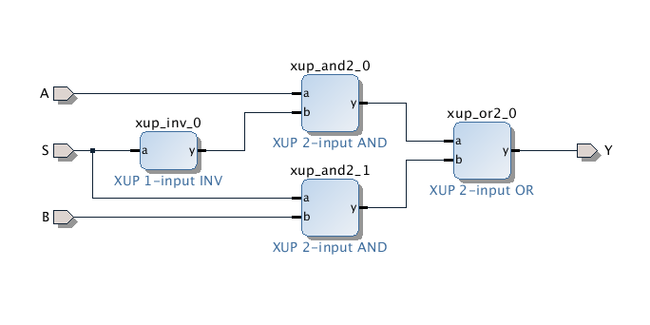

Img1: 2:1 multiplexer block design

1. Description:
   1. Truth Table:

|  |  |  |  |
| --- | --- | --- | --- |
| A | B | S | OUTPUT |
| 0 | 0 | 0 | 0 |
| 0 | 0 | 1 | 0 |
| 0 | 1 | 0 | 0 |
| 0 | 1 | 1 | 1 |
| 1 | 0 | 0 | 1 |
| 1 | 0 | 1 | 0 |
| 1 | 1 | 0 | 1 |
| 1 | 1 | 1 | 1 |

Chart1: Truth table of 2:1 multiplexer

* 1. Phenomenon on the board:
* When S=0, whether the LED lights up (output=1) or not (output=0) only depends on A, that is S chooses A;
* When S=1, whether the LED lights up (output=1) or not (output=0) only depends on B, that is S chooses B.
* We use the basic inverter which is built in Task1 to implement S’.

**TASK3: 8:1 Multiplexer**

**3.1 4:1 Mux**

1. Block Design:

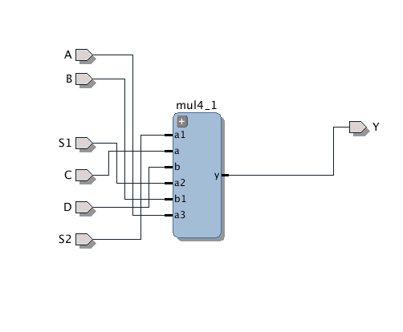

Img2: 4:1 multiplexer block design

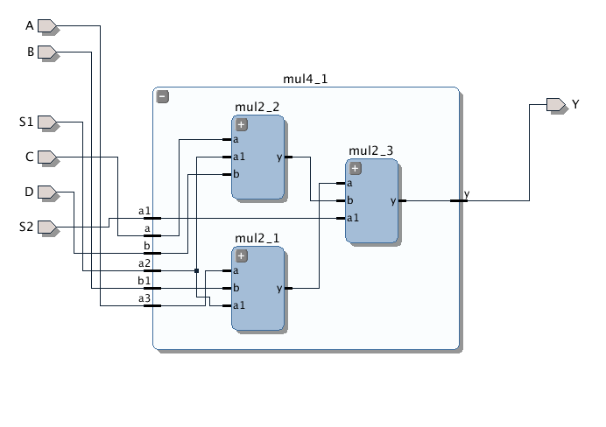

Img3: 4:1 multiplexer inner block design

1. Description:

* When S2S1=00, the output depends on A.
* When S2S1=01, the output depends on B.
* When S2S1=10, the output depends on C.
* When S2S1=11, the output depends on D.

**3.2 8:1 Mux (Without clock):**

1. Block Design:

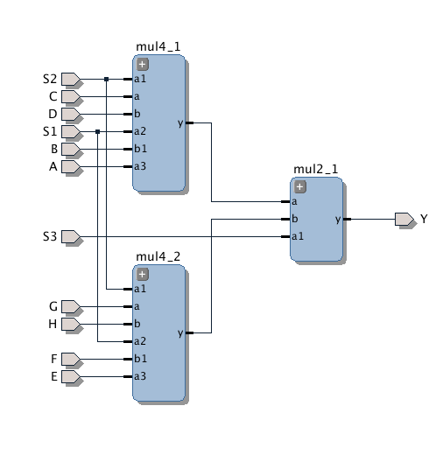

Img4: 8:1 multiplexer (without clock) block design

1. Description:

* When S3S2S1=000, the output depends on A.
* When S3S2S1=001, the output depends on B.
* When S3S2S1=010, the output depends on C.
* When S3S2S1=011, the output depends on D.
* When S3S2S1=100, the output depends on E.
* When S3S2S1=101, the output depends on F.
* When S3S2S1=110, the output depends on G.
* When S3S2S1=111, the output depends on H.

**3.3 8:1 Mux(with clock)**

1. Block Design:

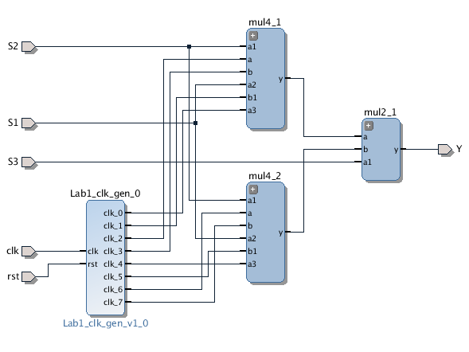

Img5: 8:1 multiplexer (with clock) block design

2. Description:

* When S3S2S1=000, the LED flashes at the frequency of 1Hz.
* When S3S2S1=001, the LED flashes at the frequency of 2Hz.
* When S3S2S1=010, the LED flashes at the frequency of 4Hz.
* When S3S2S1=011, the LED flashes at the frequency of 8Hz.
* When S3S2S1=100, the LED flashes at the frequency of 16Hz.
* When S3S2S1=101, the LED flashes at the frequency of 32Hz.
* When S3S2S1=110, the LED flashes at the frequency of 64Hz.
* When S3S2S1=111, the LED flashes at the frequency of 128Hz.